Homework Summary

Student ID | 110590034 | Student Name | 楊榮鈞
Estimated Time | __48___ hours  (The total time that you “guess” you need to spend on the homework)
Time Log | (Please extend the list if it is not enough for you)  Time spent in writing program  - From 13 : 00 to 18 : 00 (Ex: From 13:00 to 15:00)  - From 18 : 10 to 02 : 30 (Optional*)  - From 11 : 01 to 12 : 30 (Optional*)  - From 13 : 20 to 16 : 25 (Optional*)  - From 18 : 10 to 03 : 47 (Optional*)  - From 13 : 10 to 23 : 10 (Optional*)  Time spent in writing document  - From 23 : 46 to 23 : 47  - From : to : (Optional*)  * If you finished your homework in a single period, you do not need to fill the other periods.
Actual Time | __38.43___ hours  (The actual time you spent on the homework)
Difference between Estimated time and Actual Time | ___9.57__ hours (|Estimated Time – Actual Time|)  __19.9375___ % (|Estimated Time – Actual Time|/ Estimated Time)
Difficulty of the homework | (Please write down the difficulties you encountered when you did your homework)  這次的Save和Load坐起來不難，但是不知道要怎麼去做Unit Test  Thread很麻煩
Other Issues | (Any thought, learning from homework, or opinion of the homework or the course)  這次作業到最後面不知道為甚麼Dr.Smell會開不起來  只要啟動之後他就會把Visual Studio關掉  這次用到Assertion 或Exception  UndoRedo的長度是否在預想範圍  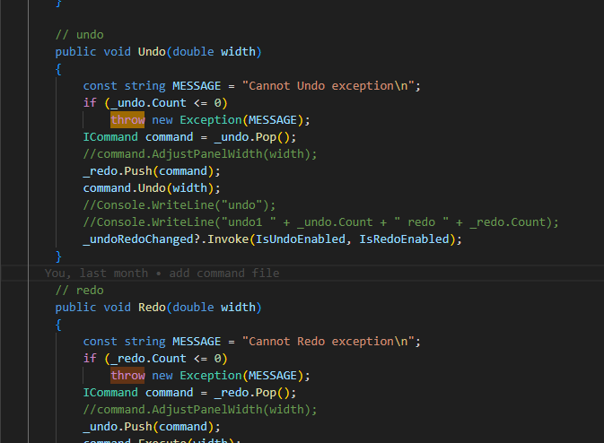  偵測是否有非預期的圖形  